Topic: Refactoring and Architectural Redesign of a Parking Lot Management System Using Design Patterns and Domain-Driven Design
- Project Summary
This project analyzes and refactors an existing Parking Lot Manager prototype.
The original system exhibited multiple design anti-patterns, including tight coupling, duplicated logic, and limited extensibility.
The system was improved through the application of object-oriented design principles and the introduction of the Factory and Strategy design patterns.
UML diagrams were used to illustrate both the original and refactored designs.
Finally, the system was re-envisioned using Domain-Driven Design (DDD) principles, resulting in a proposed microservices-based architecture capable of supporting multi-location parking operations and Electric Vehicle (EV) Charging Station Management.
- System Overview & Original Architecture
The original Parking Lot Manager is a prototype desktop application designed to manage vehicle parking within a single facility, supporting basic operations such as parking, vehicle removal, and status queries for regular and electric vehicles.
The system uses a monolithic design centered around a single ParkingLot class that combines business logic, vehicle creation, EV handling, and user interface interaction, which limits extensibility and scalability, most especially is a single-lot prototype.
- Analysis of Existing System (Anti-Patterns)
Anti-Patterns Identified in Vehicle.py
1. Code Duplication (Constructor calls)
Every subclass repeat and the duplication is not necessary
Sample Code: Vehicle.__init__(self,regnum,make,model,color)
2. Rigid Class Hierarchy
Each new vehicle type requires a new subclass:
- Car
- Truck
- Motorcycle
- Bus
This violates Open/Closed Principle (OCP)
Every time you add a new type, you must modify the code.
3. Missing Abstraction
There is no clear abstraction for what makes a vehicle other than data fields.
4. getType() Hardcoding
Each subclass returns a string manually fragile and repetitive.

Anti-Patterns Identified in ElectricVehicle.py
- Improper use of Inheritance
Sample code:
class ElectricCar:
def __init__(...):
ElectricVehicle.__init__(...)
Note: ElectricCar does NOT inherit from ElectricVehicle and this is a major design flaw.
- Code Duplication Across Vehicle Hierarchies
The electric vehicle classes duplicate attributes already defined in the regular vehicle hierarchy (regnum, make, model, color), violating the DRY principle and increasing maintenance complexity.
- Poor Extensibility for Shared Behavior
EV-specific functionality (e.g., charge state) is tightly coupled to concrete classes instead of being encapsulated as a reusable component, indicating that composition would be more appropriate than inheritance.
- Electric Types Repeat Same Pattern
ElectricCar and ElectricBike only differ by getType() suggests use of a pattern.

Anti-Patterns Identified in ParkingManager.py
- God Class and Violation of Single Responsibility Principle
The ParkingManager (or ParkingLot) class centralizes multiple unrelated responsibilities, including vehicle creation, parking allocation logic, EV handling, searching and reporting, and direct interaction with the Tkinter user interface. This results in a monolithic design that is difficult to test, extend, and maintain.

- Tight Coupling Between Business Logic and UI
Core parking logic directly accesses GUI components (e.g., text fields and UI state), tightly coupling the domain logic to the presentation layer. This prevents reuse of the core logic in other contexts (e.g., APIs or services) and violates separation of concerns.
- Excessive Conditional Logic (Conditional Complexity)
Vehicle type selection and parking behavior rely on deeply nested conditional statements (e.g., EV vs non-EV, car vs motorcycle). This conditional complexity violates the Open/Closed Principle and makes the code fragile when introducing new vehicle types or behaviors.
- Excessive Conditional Logic (Conditional Complexity)
Vehicle type selection and parking behavior rely on deeply nested conditional statements (e.g., EV vs non-EV, car vs motorcycle). This conditional complexity violates the Open/Closed Principle and makes the code fragile when introducing new vehicle types or behaviors.
- Primitive Obsession and Poor State Modeling
Parking slots are represented using primitive values (such as -1 for empty slots) instead of explicit domain objects. This leads to unclear state management, reduces code readability, and increases the risk of logical errors.

  - Vehicle & ElectricVehicle Design Issues
- Code duplication
- Improper inheritance
- Rigid class hierarchy
  - ParkingManager Design Issues
- God Class
- GUI coupling
- Conditional logic
- Primitive obsession
- ORIGINAL UML DIAGRAMS (BEFORE REFACTORING)
These diagrams describe the system as originally implemented, before applying any design patterns or architectural improvements.

  - ORIGINAL CLASS DIAGRAM (STRUCTURAL – BEFORE)
- ParkingLot as a God Class
- Tight coupling to:
- Vehicle
- ElectricVehicle
- Concrete subclasses
- No Slot abstraction
- EV and non-EV modeled as separate hierarchies
- No factory or strategy usage
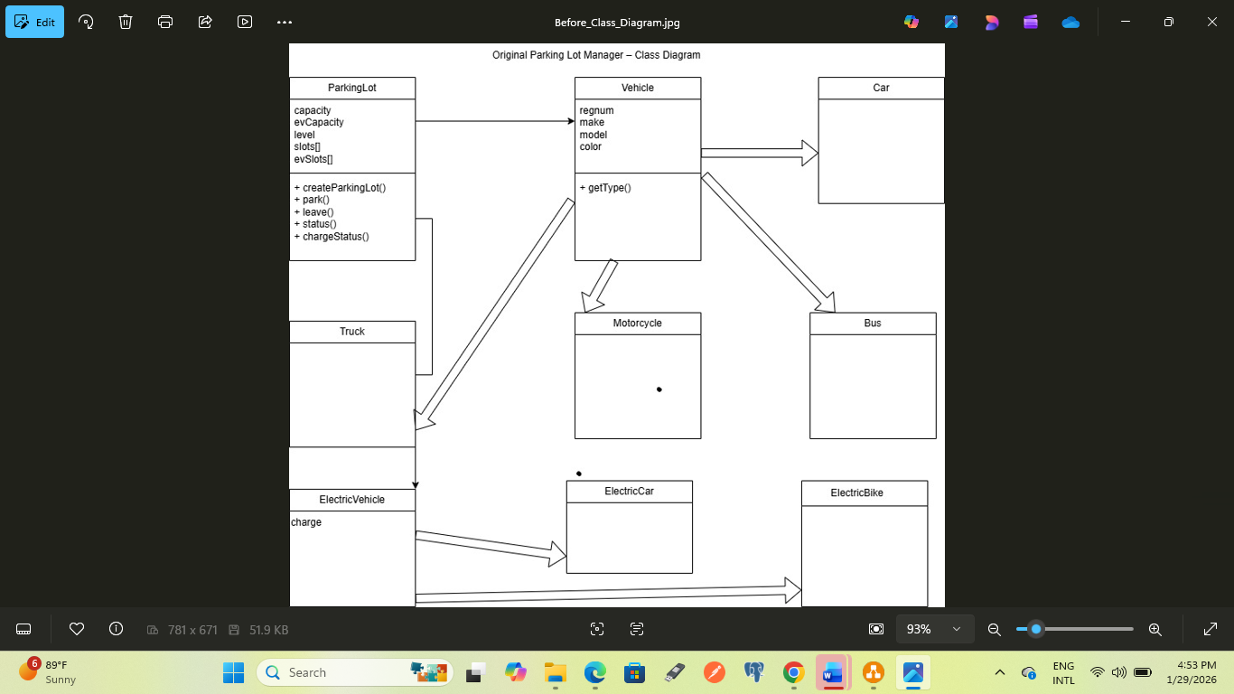
Figure 1: Snapshot of Original Parking Lot Manager – Class Diagram
Figure 1: Class diagram representing the original Parking Lot Manager design before refactoring. The diagram highlights tight coupling between the ParkingLot class and concrete vehicle implementations, as well as the absence of clear separation of concerns.

  - ORIGINAL SEQUENCE DIAGRAM (BEHAVIORAL)—BEFORE
Scenario: User parks a vehicle
actor User
User -> ParkingLot : park(regnum, make, model, color, ev, motor)
ParkingLot -> ParkingLot : check capacity
ParkingLot -> ElectricVehicle : create EV (if ev=1)
ParkingLot -> Vehicle : create non-EV (if ev=0)
ParkingLot -> ParkingLot : update slot arrays
ParkingLot --> User : slot number
Problem clearly visible: ParkingLot does everything.

- Refactoring Strategy & Design Decisions
  - Refactoring Goals
- Reduce coupling
- Improve extensibility
- Prepare for EV & multi-site scaling
  - Selected Design Patterns
- Factory Pattern (why chosen)
- Strategy Pattern (why chosen)
- Composition over inheritance (EV behavior)
- Refactored Architecture & Code Structure
class ParkingLot {
- slots : List<Slot>
- strategy : ParkingStrategy
+ park(vehicle)
+ leave(slotId)
}

class Slot {
- vehicle
+ isFree()
+ park(vehicle)
+ remove()
}

interface ParkingStrategy {
+ findSlot(slots)
}

class RegularParkingStrategy
class EVParkingStrategy

ParkingStrategy <|.. RegularParkingStrategy
ParkingStrategy <|.. EVParkingStrategy

class Vehicle {
regnum
make
model
color
+ getType()
}

class ElectricMixin {
charge
+ setCharge()
+ getCharge()
}

class Car
class Motorcycle
class ElectricCar
class ElectricBike

Vehicle <|-- Car
Vehicle <|-- Motorcycle
Car <|-- ElectricCar
Motorcycle <|-- ElectricBike
ElectricMixin <|-- ElectricCar
ElectricMixin <|-- ElectricBike

class VehicleFactory {
+ createVehicle()
}

ParkingLot --> Slot
ParkingLot --> ParkingStrategy
ParkingLot --> Vehicle
ParkingLot --> VehicleFactory

  - Refactored — Sequence Diagram (Behavioral)
Scenario: User parks an electric vehicle (refactored flow)
actor User
User -> ParkingLot : park(vehicle)
ParkingLot -> ParkingStrategy : findSlot(slots)
ParkingStrategy --> ParkingLot : available Slot
ParkingLot -> Slot : park(vehicle)
Slot --> ParkingLot : success
ParkingLot --> User : slot number
  - REFACTORED CODE ARCHITECTURE
parking_system/
│
├── domain/
│ ├── vehicle.py
│ ├── slot.py
│ ├── parking_lot.py
│ └── charging.py
│
├── services/
│ ├── parking_service.py
│ ├── charging_service.py
│ └── billing_service.py
│
├── strategies/
│ ├── parking_strategy.py
│ ├── regular_parking_strategy.py
│ └── ev_parking_strategy.py
│
├── factories/
│ └── vehicle_factory.py
│
├── ui/
│ └── tkinter_adapter.py
│
└── main.py

  - Key Architectural Changes
- Slot abstraction
- ParkingLot as coordinator
- UI adapter
- Service layer

  - Old → New File Mapping
Original File | Original Responsibility | Refactored File(s) | Reason for Change
ParkingManager.py | God class handling GUI, parking logic, EV logic, searching, reporting, and object creation | domain/parking_lot.py services/parking_service.py ui/tkinter_adapter.py | Split to enforce Single Responsibility Principle (SRP) and decouple UI from business logic
Vehicle.py | Vehicle data model and concrete vehicle types | domain/vehicle.py | Centralized all vehicle logic into a single domain module
ElectricVehicle.py | EV-specific vehicle hierarchy (duplicate logic) | domain/vehicle.py (via ElectricMixin) | Removed duplication and applied composition over inheritance
Vehicle creation logic (inside ParkingManager.py) | Hard-coded conditional object creation | factories/vehicle_factory.py | Introduced Factory Pattern to eliminate conditional logic and support extensibility
Slot arrays using -1 | Primitive slot representation | domain/slot.py | Replaced magic values with explicit Slot domain object
Parking allocation logic (mixed with parking logic) | Embedded EV vs non-EV logic | strategies/parking_strategy.py strategies/regular_parking_strategy.py strategies/ev_parking_strategy.py | Applied Strategy Pattern to allow flexible parking rules
EV charge handling logic | Mixed with parking logic | domain/charging.py | Isolated EV charging concerns for DDD alignment
Direct GUI calls in domain logic | Tight coupling to Tkinter | ui/tkinter_adapter.py | Decoupled UI from core system for testability and reuse

Note: The original prototype consisted of a small number of files with overlapping responsibilities, most notably the ParkingManager.py file, which acted as a God Class.
During refactoring, responsibilities were redistributed across clearly defined layers, including domain, service, factory, strategy, and user interface layers.
This reorganization improves maintainability and extensibility by enforcing separation of concerns and aligning the system structure with Domain-Driven Design principles. The resulting architecture also provides a natural transition path toward a microservices-based deployment, as each domain module maps directly to a potential independent service.

  - Refactored UML Diagrams (AFTER)

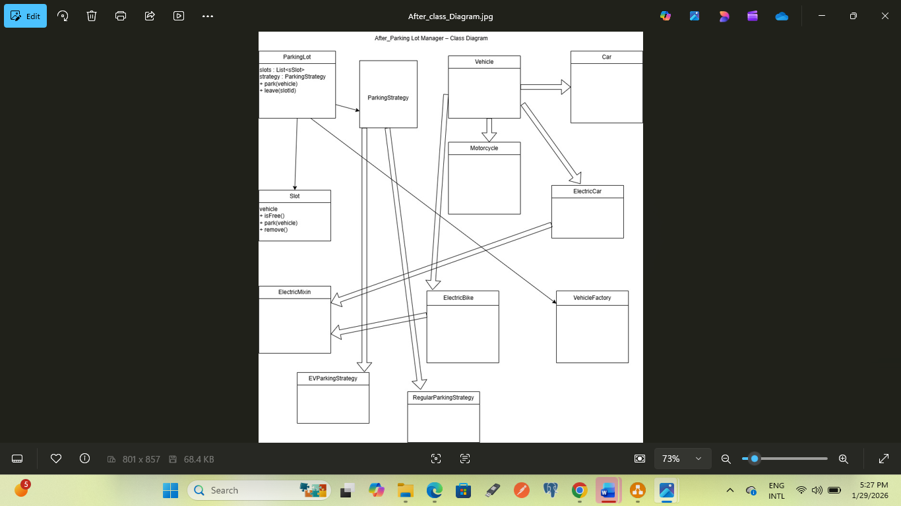
Figure 2: Snapshot of Refactored Parking Lot Manager – Class Diagram
- Domain-Driven Design (DDD)
  - Overview
Domain-Driven Design (DDD) was applied to align the Parking Lot Manager system with EasyParkPlus’s business operations and to support future expansion, including Electric Vehicle (EV) Charging Station Management.
The system was decomposed into a core domain, supporting subdomains, and clearly defined bounded contexts to improve scalability and maintainability.
Supporting Subdomains:
Subdomain | Responsibility
Parking Management | Slot allocation and vehicle tracking
EV Charging Management | Charging stations and charging sessions
Billing & Payment | Fee calculation and payments
User Management | Authentication and user roles
Facility Management | Multi-location and floor layouts
  - Bounded Contexts
Each subdomain was modeled as a bounded context with a clearly defined scope.
Bounded Context | Responsibility
Parking Context | Parking slots, vehicles, occupancy
EV Charging Context | Charging stations and sessions
Billing Context | Invoicing and payments
User Context | User authentication and roles
Facility Context | Parking facilities and floors
  - Ubiquitous Language
- ParkingLot: A collection of managed parking slots
- Slot: A single parking space
- ChargingStation: An EV charging unit
- ChargingSession: An active EV charging period
This shared terminology ensures consistent communication across the system.
  - Domain Models
Parking Management Domain
- Entities: ParkingLot, Slot, Vehicle
- Value Objects: SlotID, RegistrationNumber, VehicleType
- Aggregate Root: ParkingLot
EV Charging Domain
- Entities: ChargingStation, ChargingSession, ElectricVehicle
- Value Objects: EnergyConsumed, ChargingRate, Duration
- Aggregate Root: ChargingStation
Billing Domain
- Entities: Invoice, Payment
- Value Objects: Money, Currency, TimeDuration
- Aggregate Root: Invoice
- Microservices Architecture Design
Each bounded context becomes one microservice.
Microservice | Bounded Context | Responsibility | Database
Parking Service | Parking Context | Slot allocation, vehicle tracking | parking_db
EV Charging Service | Charging Operations Context (Core Domain) | Charging sessions, stations | ev_charging_db
Billing Service |  | Pricing, payments | billing_db
  Billing Context
User Service | Identity & Access Context | Auth, staff mgmt | user_db
Facility Service |  | Multi-site mgmt | facility_db
  Facility Context

8.1 Key DDD Design Notes
Clear Bounded Context Ownership
- Each service owns one business capability
- No service reaches directly into another service’s database
- Cross-context communication happens via APIs or domain events
8.2 Core vs Supporting Domains
- Core Domain:
EV Charging Service (charging lifecycle & charger availability)
- Supporting Domains:
Parking, Facility, Billing
- Generic Domain:
User Service (auth & staff management)
8.3 Database-per-Service Rule
Each microservice has:
- Its own schema
- Its own data model
- Full control over persistence
This avoids:
- Tight coupling
- Cross-service transactions
- Accidental data leakage

8.4. Example Responsibility Boundaries
- Facility Service
  - Knows where chargers and parking slots exist
  - Does not know charger status or pricing
- Parking Service
  - Knows parking slot occupancy
  - Can raise events like ParkingSlotBlocked
  - Does not manage charging logic
- EV Charging Service
  - Owns charger state and session lifecycle
  - Publishes events like ChargingStarted, ChargingCompleted
- Billing Service
  - Reacts to charging completion events
  - Calculates cost independently
8.5 Event-Driven Integration
Typical flow:
- Charging session completes (EV Charging Service)
- ChargingCompleted event emitted
- Billing Service consumes event calculates cost
- Operations dashboard updates projections
This preserves autonomy while enabling collaboration.
- API Gateway
An API Gateway acts as the single entry point for external clients. It routes requests to the appropriate microservices and hides internal service boundaries from clients. This approach simplifies client interaction and supports centralized concerns such as authentication and request routing.

  - Service APIs
Parking Service
POST /parking/park
POST /parking/leave
GET /parking/status
GET /parking/slot/{registrationNumber}

EV Charging Service
POST /ev/start-session
POST /ev/stop-session
GET /ev/status
GET /ev/chargers

Billing Service
POST /billing/calculate
POST /billing/pay
GET /billing/invoice/{invoiceId}

User Service
POST /users/login
POST /users/register
GET /users/{userId}

  - Data Management
Each microservice maintains its own dedicated database, preventing shared persistence and reducing coupling between services. This design supports independent scaling, fault isolation, and service autonomy.

